**13. ReactJS-HOL**

1.Setup Project

|  |
| --- |
| >npx create-react-app bloggerapp |

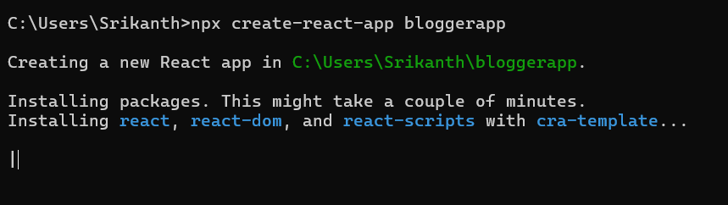  
2.Update App.js

|  |
| --- |
| App.js  import React from "react";  import "./App.css";  function App() {    const books = [      { id: 1, bname: "Master React", price: 670 },      { id: 2, bname: "Deep Dive into Angular 11", price: 800 },      { id: 3, bname: "Mongo Essentials", price: 450 },    ];    const blogs = [      {        id: 1,        title: "React Learning",        author: "Stephen Biz",        content: "Welcome to learning React!",      },      {        id: 2,        title: "Installation",        author: "Schwezdenier",        content: "You can install React from npm.",      },    ];    const courses = [      { id: 1, name: "Angular", date: "4/5/2021" },      { id: 2, name: "React", date: "6/3/20201" },    ];    const bookdet = (      <ul>        {books.map((book) => (          <div key={book.id}>            <h3>{book.bname}</h3>            <h4>{book.price}</h4>          </div>        ))}      </ul>    );    const content = (      <ul>        {blogs.map((blog) => (          <div key={blog.id}>            <h3>{blog.title}</h3>            <h4>{blog.author}</h4>            <p>{blog.content}</p>          </div>        ))}      </ul>    );    const coursedet = (      <ul>        {courses.map((course) => (          <div key={course.id}>            <h3>{course.name}</h3>            <h4>{course.date}</h4>          </div>        ))}      </ul>    );    return (      <div>        <div className="container">          <div className="st2">            <h1>Book Details</h1>            {bookdet}          </div>          <div className="v1">            <h1>Blog Details</h1>            {content}          </div>          <div className="mystyle1">            <h1>Course Details</h1>            {coursedet}          </div>        </div>      </div>    );  }  export default App; |

3. Update App.css

|  |
| --- |
| App.css  .container {    display: flex;    justify-content: space-around;    margin-top: 50px;    font-family: Arial, sans-serif;  }  .st2, .v1, .mystyle1 {    width: 30%;    border-left: 4px solid green;    padding-left: 20px;  }  h1 {    font-size: 22px;  }  h3 {    font-weight: bold;    font-size: 18px;  }  h4 {    font-weight: normal;    font-size: 16px;    margin-bottom: 10px;  }  p {    font-size: 14px;  } |

**OUTPUT:**

